43.10: a)
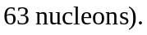
b) In Eq. (43.11), Z = 29 and N = 34, so the fifth term is zero. The predicted binding energy is
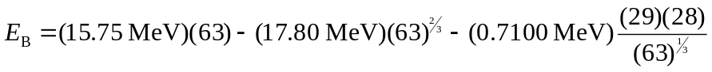
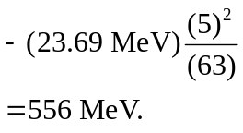
(The fifth term is zero since the number of neutrons is even while the number of protons is odd, making the pairing term zero.)
This result differs from the binding energy found from the mass deficit by 0.86%, a very good agreement comparable to that found in Example 43.4.

